ADGM DPR Compliance for Log360 Cloud
Automate ADGM DPR compliance and fortify cybersecurity resilience for financial institutions with Log360.
Region: EU, UAE | Type: Data Privacy, Financial Services | Category: Compliance | Pricing: Free

Overview
The ADGM DPR compliance extension in Log360 helps organizations meet the Abu Dhabi Global Market Data Protection Regulations 2021 (ADGM DPR), the GDPR-aligned privacy law for ADGM financial free zone entities enforced by the Office of Data Protection by providing centralized log management, real-time access monitoring, and automated breach detection. The platform supports ADGM DPR requirements for data security controls, breach detection and notification, data subject rights management, processing audit trails, cross-border transfer monitoring, accountability governance, and DPIA support.
For Lawful Basis and Consent Management, Log360 monitors authentication events, MFA activities, and database access logs to provide evidence of authorized processing and support regulatory audit reviews. To address Data Security and Access Controls, the platform tracks user logon activities, failed access attempts, and privileged account usage across Windows, Unix, and Active Directory to detect unauthorized data access. The extension also supports Personal Data Breach Detection and Response by providing capabilities that monitors anomalous access patterns, threat detection events, and network attack reports across all environments to identify breaches and support timely notification.

Key Features
- Data Subject Rights Management: Log360 audits database DDL and DML changes, tracks record modifications, and monitors administrative actions affecting personal data repositories to demonstrate rights fulfillment.
- Processing Activity Audit Trails (ROPA): Log360 centralizes event logs from databases, operating systems, and identity platforms, generating tamper-evident processing audit trails for inspections.
- Data Protection Impact Assessment Support: Log360 tracks policy changes, firewall configuration audits, and GPO monitoring to support risk assessment workflows and DPIA documentation for privacy officers.
- Cross-Border Data Transfer Controls: Log360 monitors cloud storage activities, AWS data transfer events, and third-party integration logs to track and audit cross-border personal data flows comprehensively.
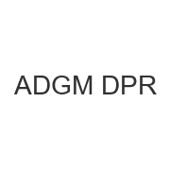
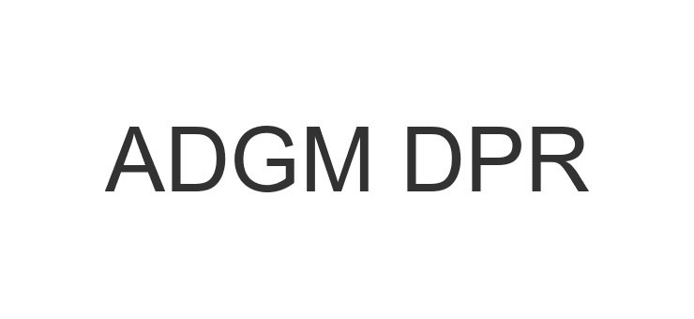
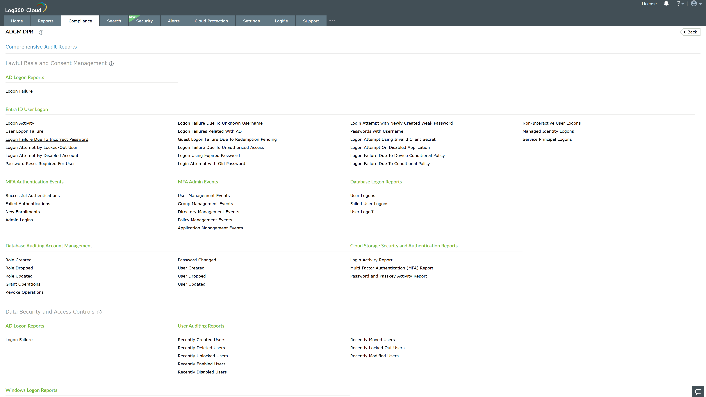
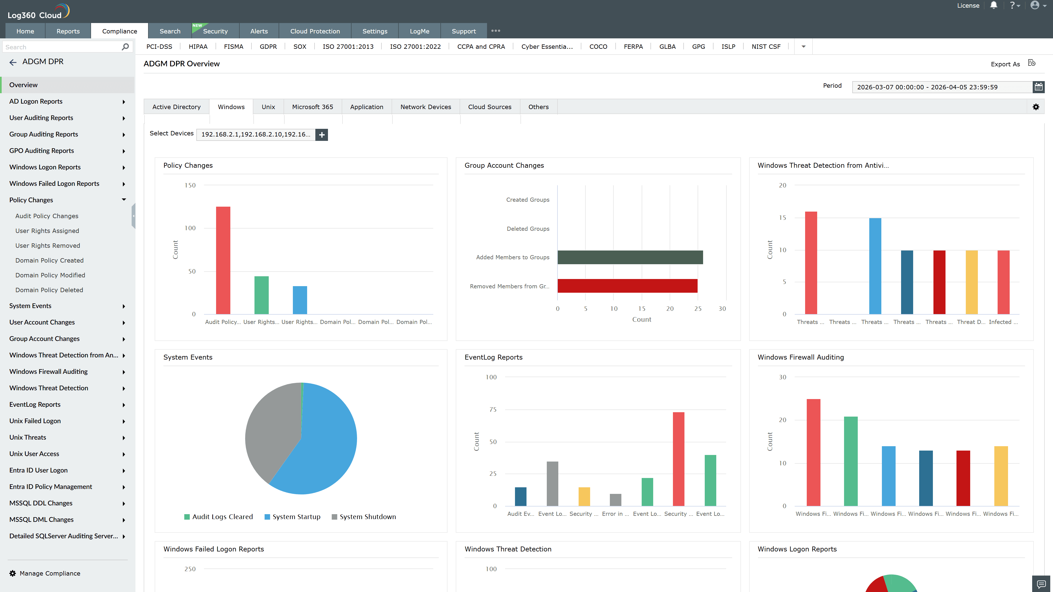
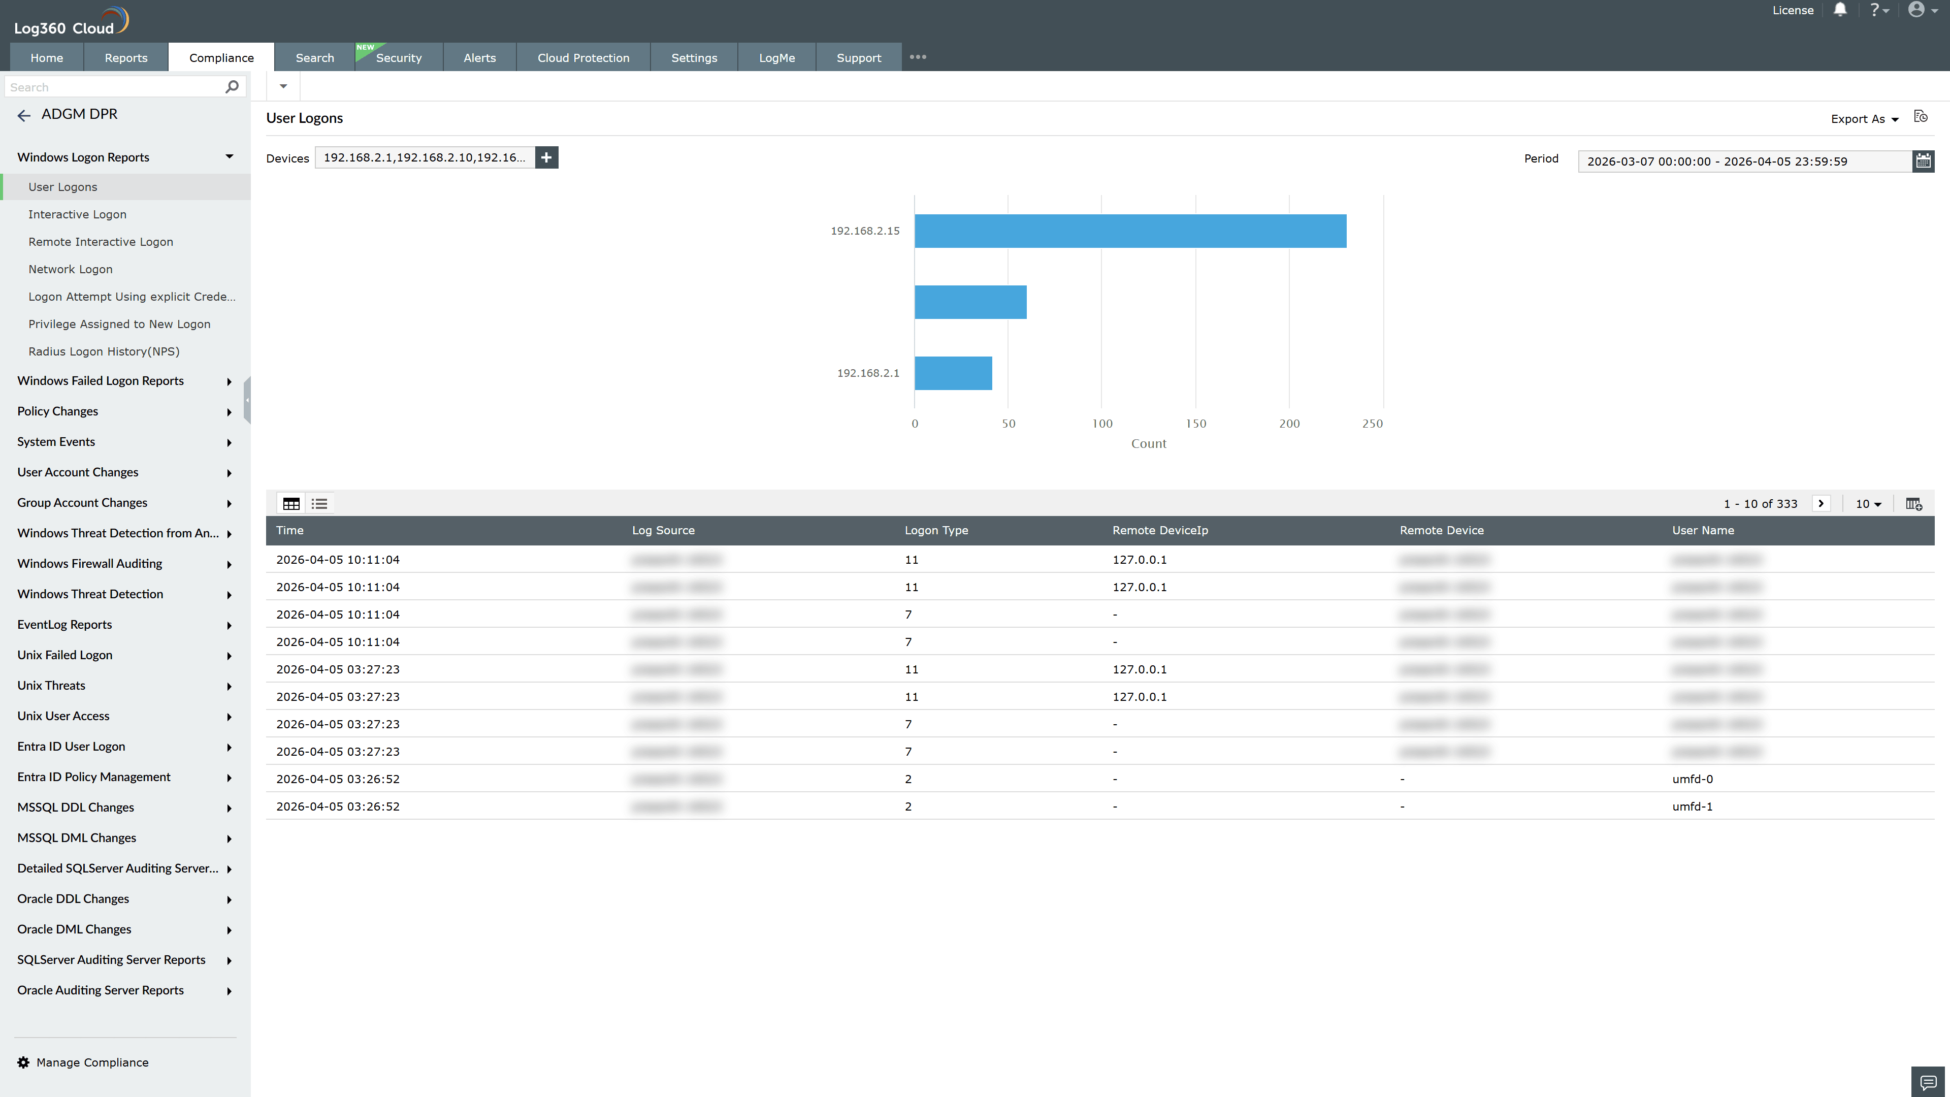
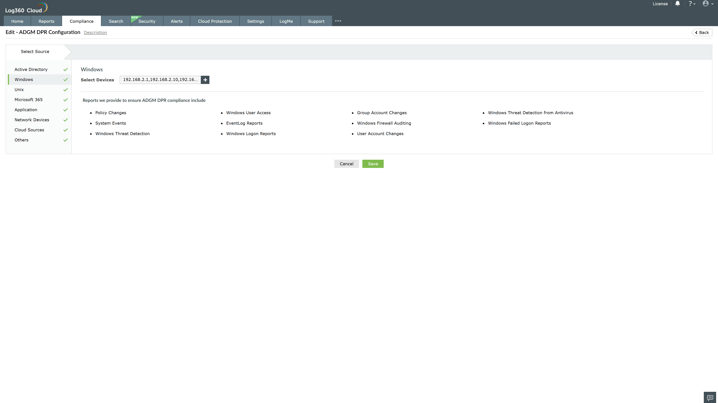
Valid Submission : Yes
Supported Editions : Free, Basic, Standard, Professional, MSSP
Help Document : https://www.manageengine.com/log-management/help/integrations/compliance-extensions.html
Help Video : Not provided
Tags : Log360, Compliance, Privacy monitoring, Data privacy, Regulatory compliance
Supported DCs : US, IN, JP, CA, AU, UK and EU
Privacy Policy:
Terms of Service:
Release Notes:
Predefined reports for the ADGM DPR.

